**NAME: MATHEW LYON DAVID**

**MATRIC NO: HCSF/23/0079**

**COURSE CODE: COM 324**

**COURSE TITLE: SOFTWARE ENGINEERING**

1. Create a Flow Chart illustrating the stages of the SDLC process

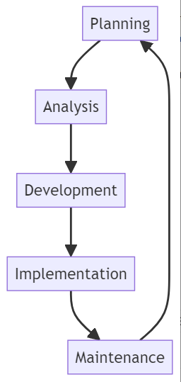

2. Create a Gantt Chart to represent the timeline and dependencies for each phase of the SDLC. Additionally, for the scenario of a customer purchasing goods at a market:

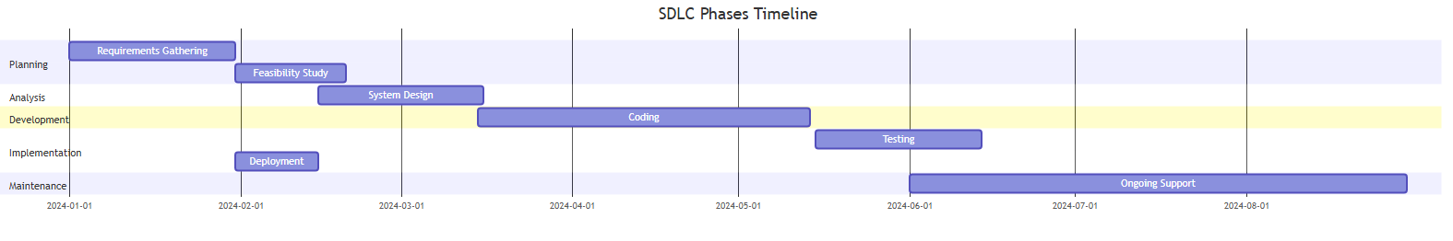

### 3. Activity Diagram Depicting the Steps a Customer Takes to Buy Goods

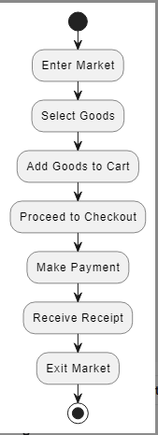

### UML Diagram Modeling the Interactions Between the Customer and the System During the Purchase Process

